**Service Fabric cluster**

1. **using visual studio create application**

File->new->project->cloud->service fabric application

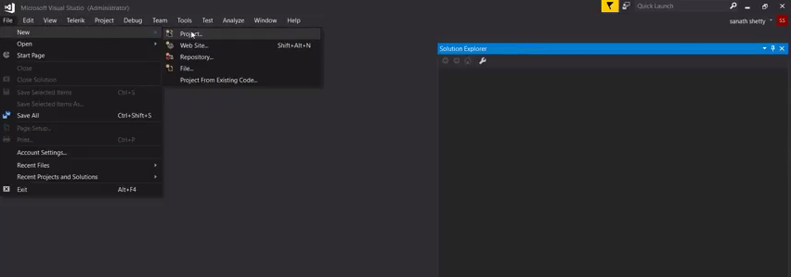

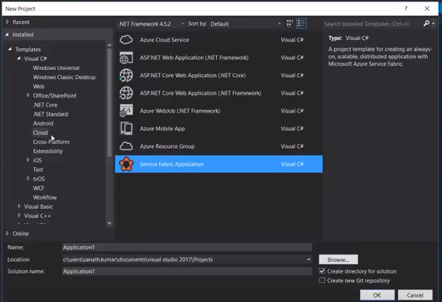

**Can use any template**

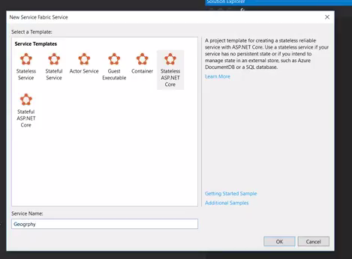

* 1. **click F5 to build**

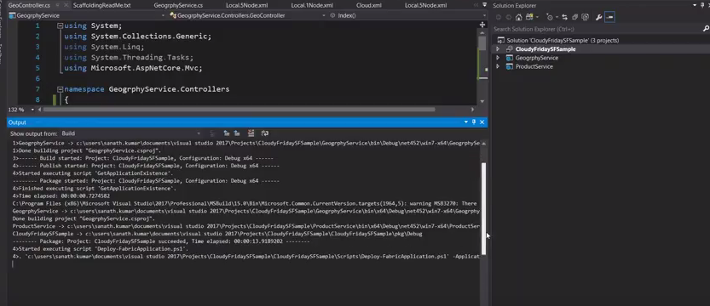

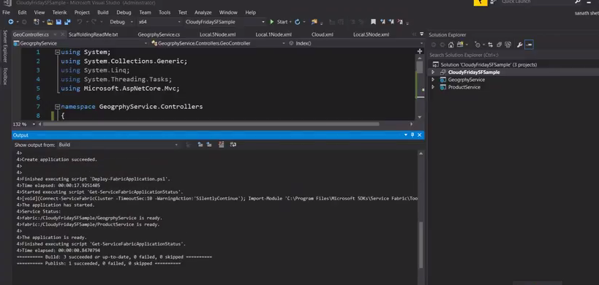

**2.2 .can able to run application in local service fabric cluster**

**By default application will run on local cluster,**

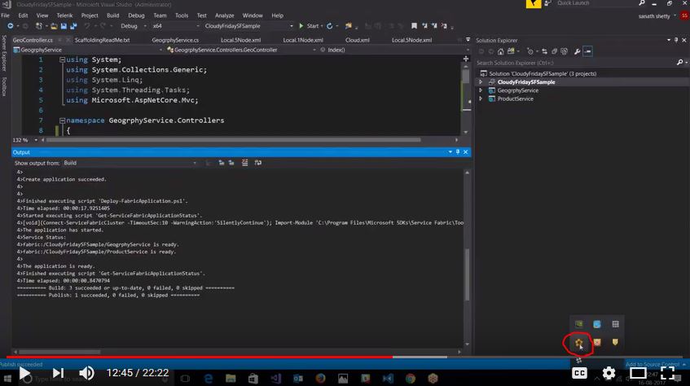

**In Browser,type**

[**http://loaclhost:19080**](http://loaclhost:19080)

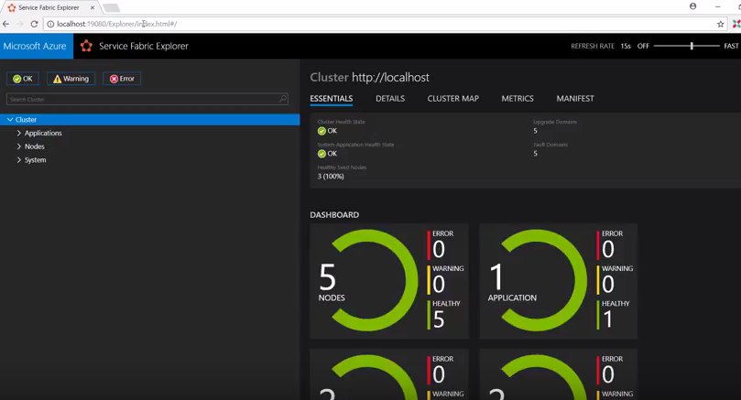

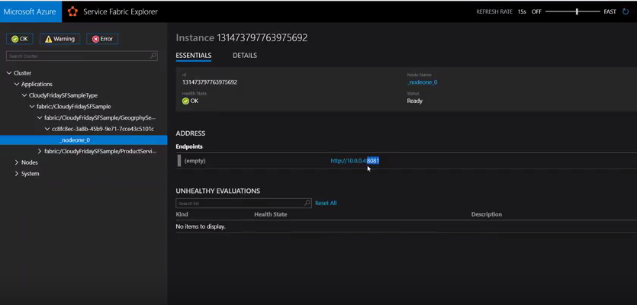

You can access application ,

http://<local_cluster_name>:<application_port>/

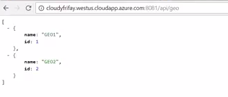

1. **Deploy the application using Visual Studio**

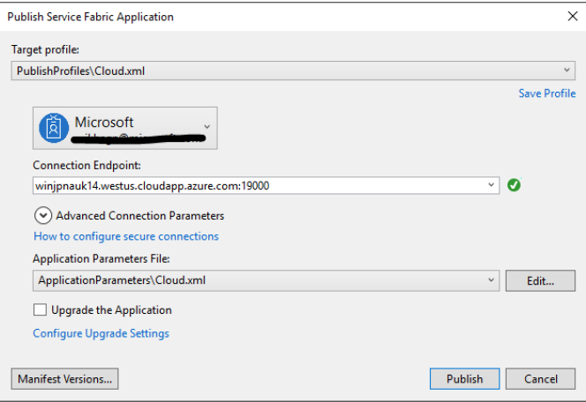

* 1. Type in the Connection Endpoint of the cluster in the **Connection Endpoint** field and click **Publish**. When

signing up for the Party Cluster, the Connection Endpoint is provided in the browser. - for example,

winh1x87d1d.westus.cloudapp.azure.com:19000 .

* 1. Open a browser and type in the cluster address foolowed by ':8080' to get to the applicaiton in the cluster

for example, http://winh1x87d1d.westus.cloudapp.azure.com:8080 . You should now see the application

running in the cluster in Azure.

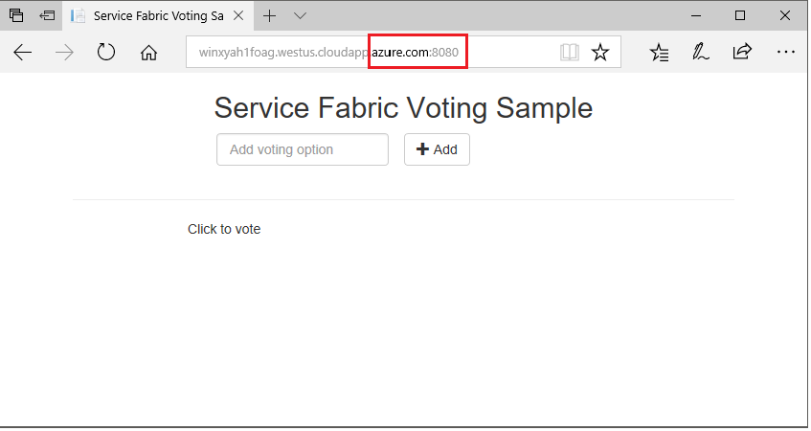

1. **Scale applications and services in a cluster**
   1. To scale the web front-end service, do the following steps:
   2. Open Service Fabric Explorer in your cluster - for example, http://winh1x87d1d.westus.cloudapp.azure.com:19080 .
   3. Click on the ellipsis (three dots) next to the fabric:/Voting/VotingWeb node in the treeview and choose
   4. Scale Service.

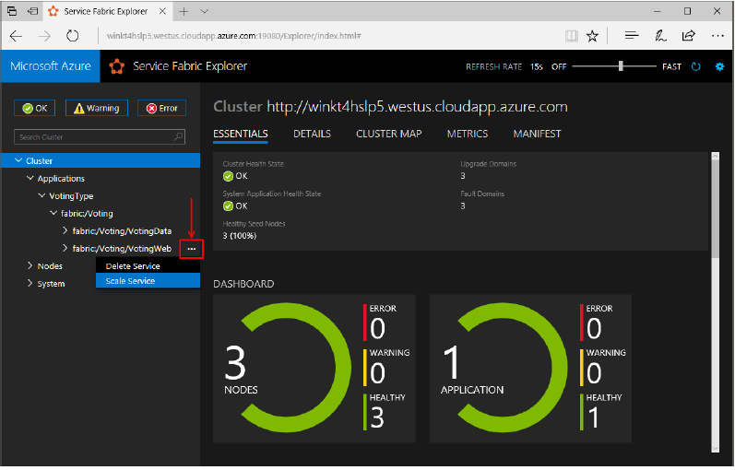

* 1. You can now choose to scale the number of instances of the web front-end service.
  2. Change the number to 2 and click Scale Service.
  3. Click on the fabric:/Voting/VotingWeb node in the tree-view and expand the partition node (represented by a GUID).

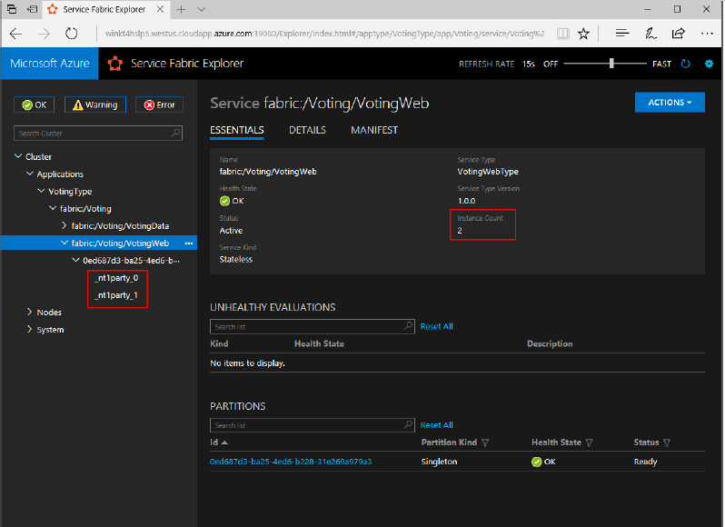

1. **Perform a rolling application upgrade**
   1. Make some changes in your application
   2. Save the file.
   3. Right-click Voting in the Solution Explorer and choose Publish. The Publish dialog appears.
   4. Click the Manifest Version button to change the version of the service and application.
   5. Change the version of the Code element under VotingWebPkg to "2.0.0", for example, and click Save.

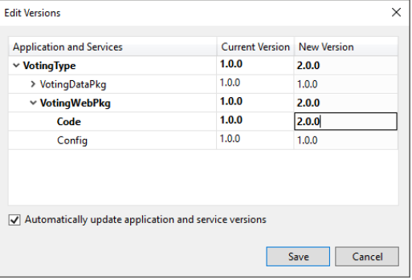

* 1. In the Publish Service Fabric Application dialog, check the Upgrade the Application checkbox, and click Publish

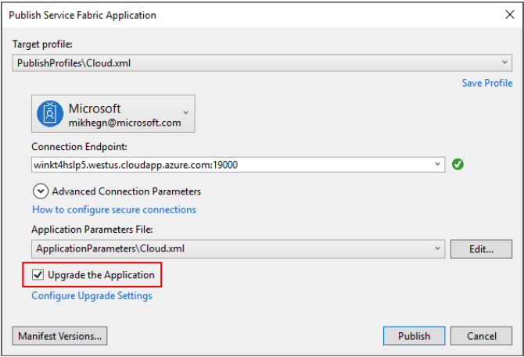

* 1. Open your browser and browse to the cluster address on port 19080 - for example,

http://winh1x87d1d.westus.cloudapp.azure.com:19080 .

* 1. In the Publish Service Fabric Application dialog, check the Upgrade the Application checkbox, and click Publish.
  2. Click on the Applications node in the tree view, and then Upgrades in Progress in the right-hand pane.

You see how the upgrade rolls through the upgrade domains in your cluster, making sure each domain is

healthy before proceeding to the next.

